**ADDRESS BOOK**

ADDRESS BOOK



CONTENTS

Introduction …………………………………………………………………………………………

Acknowledgment………………………………………………………………………………….

Requirements……………………………………………………………………………………….

E-Project Analysis…………………………………………………………………………………..

User Guide……………………………………………………………………………………………

Coding………………………………………………………………………………………………….



**SUBMITED BY**

* **NAZIA ROSHAN**
* **SOUBAN SHAHID**
* **AHMED TADEEB**

Of batch **PR2-202212F** have successfully completed the given task for the topic

**FACULTY: SIR TALHA**

SEMESTER DISM

APTECH LEARNING SHAHRAH-E-FAISAL

**INTRODUCTION**

The thirst for learning, upgrading technical skills and applying the concepts in rea life environment at a fast pace is what the industry demands from IT professionals today. However busy work schedules, far-flung locations, unavailability of convenient time-slots pose as major barriers when it comes to applying the concepts into realism. And hence the need to look out for alternative means of implementation in the form of laddered approach. The above truly pose as constraints especially for our students too! With their busy schedules, it is indeed difficult for our students to keep up with the genuine and constant need for integrated application which can be seen live especially so in the field of IT education where technology can change on the spur of a moment. Well, technology does come to our rescue at such times!!Keeping the above in mind and in tune with our constant endeavour to use Technology in our training model, we at Aptech have thought of revolutionizing the way our students learn and implement the concepts using tools themselves by providing a live and synchronous e-Project learning environment!

**ACKNOWLEDGE**

The thirst for learning, upgrading technical skills and applying the concepts in real life environment at a fast pace is what the industry demands from IT professionals today. However busy work schedules, far-flung locations, unavailability of convenient time-slots pose as major barriers when it comes to applying the concepts into realism. And hence the need to look out for alternative means of implementation in the form of laddered approach. The above truly pose as constraints especially for our students too! With their busy schedules, it is indeed difficult for our students to keep up with the genuine and constant need for integrated application which can be seen live especially so in the field of IT education where technology can change on the spur of a moment. Well, technology does come to our rescue at such times!! Keeping the above in mind and in tune with our constant endeavour to use technology in our training model, we at Aptech have thought of revolutionizing the way our students learn and implement the concepts using tools themselves by providing a live and synchronous e-Project learning environment!



**WHAT IS THIS E-PROJECT?**

e-Project is a step-by-step learning environment that closely simulates the classroom and Lab based learning environment into actual implementation. It is a project implementation at your fingertips!! An electronic, live juncture on the machine that allows you to

* Practice step by step i.e. laddered approach.
* Build a larger more robust application.
* Usage of certain utilities in applications designed by user.
* Single program to unified code leading to a complete application.
* Learn implementation of concepts in a phased manner.
* Enhance skills and add value.
* Work on real life projects.
* Give a real life scenario and help to create applications more complicated and useful.
* Mentoring through email support.

**OBJECTIVE OF THIS EPROJECT**

The Objective of this program is to give a sample project to work on real life projects. These applications help you build a larger more robust application.

The objective is not to teach you concepts but to provide you with a real life scenario and help you create applications using the tools.

You can revise them before you start with the project.

It is very essential that a student has a clear understanding of the subject.

Kindly get back to e-Projects Team in case of any doubts regarding the application or its objectives.

**REQUIRMENTS**

The Web site is to be created based on the following requirements.

The user should be able to do the following:

1. Browse through the categories and products available and should be able to add products to the shopping basket.
2. User should be able to specify the quantity of the products required.
3. Complete / Finalize the order.
4. While ordering the product the user should input the following information:
   * Name
   * Address
   * E-mail
   * Work Phone No.
   * Cell No.
   * Date Of Birth
   * Category
   * Remarks(other additional informational)
5. The user should be able to search a product by name.

Administrator should be able to do the following:

1. Add/Delete categories and products into the website.

1. Update the information for the existing products.
2. Maintenance of the web site
3. Add / Delete records in database.
4. Backup the database.
5. Generate/View the report upon top 10 best selling products.
6. Generate/View the report upon top 10 clients/users (doing maximum shopping).

**PROJECT ANALYSIS**

|  |  |
| --- | --- |
| NAME | ENROLLMENT NO |
| NAZIA ROSHAN | Student 1444337 |
| SOUBAN SHAHID | Student 1440061 |
| AHMED TADEEB | Student 1445229 |
| TEACHER: SIR TALHA | BATCH CODE:PR2-202207F1 |

|  |  |  |  |  |  |  |  |  |
| --- | --- | --- | --- | --- | --- | --- | --- | --- |
| NAME | Amin-panel | User-panel | About-us | Add-to-cart | Ui-website | Support | DOCUME  NTATION | design |
| NAZIA |  |  |  |  |  |  |  |  |
| SOUBAN |  |  |  |  |  |  |  |  |
| AHMED |  |  |  |  |  |  |  |  |

**ADDRESS BOOK**



Jenny is a doing business of cosmetics and imitation jewelry. She operates from home. Initially she started the entire activity by contacting the nearby friends and relatives, inform them about the various products available with her and their prices. Maria used to maintain the catalogue of products to display and diary for contacting the clients wherein she used to record their contact details and also to record their orders.

With the growing demands of the business and as the number of clients is increasing day by day, she wishes to have a web site with the complete product list for the user, also user should be able to place the order using the website.

HOME MANUAL

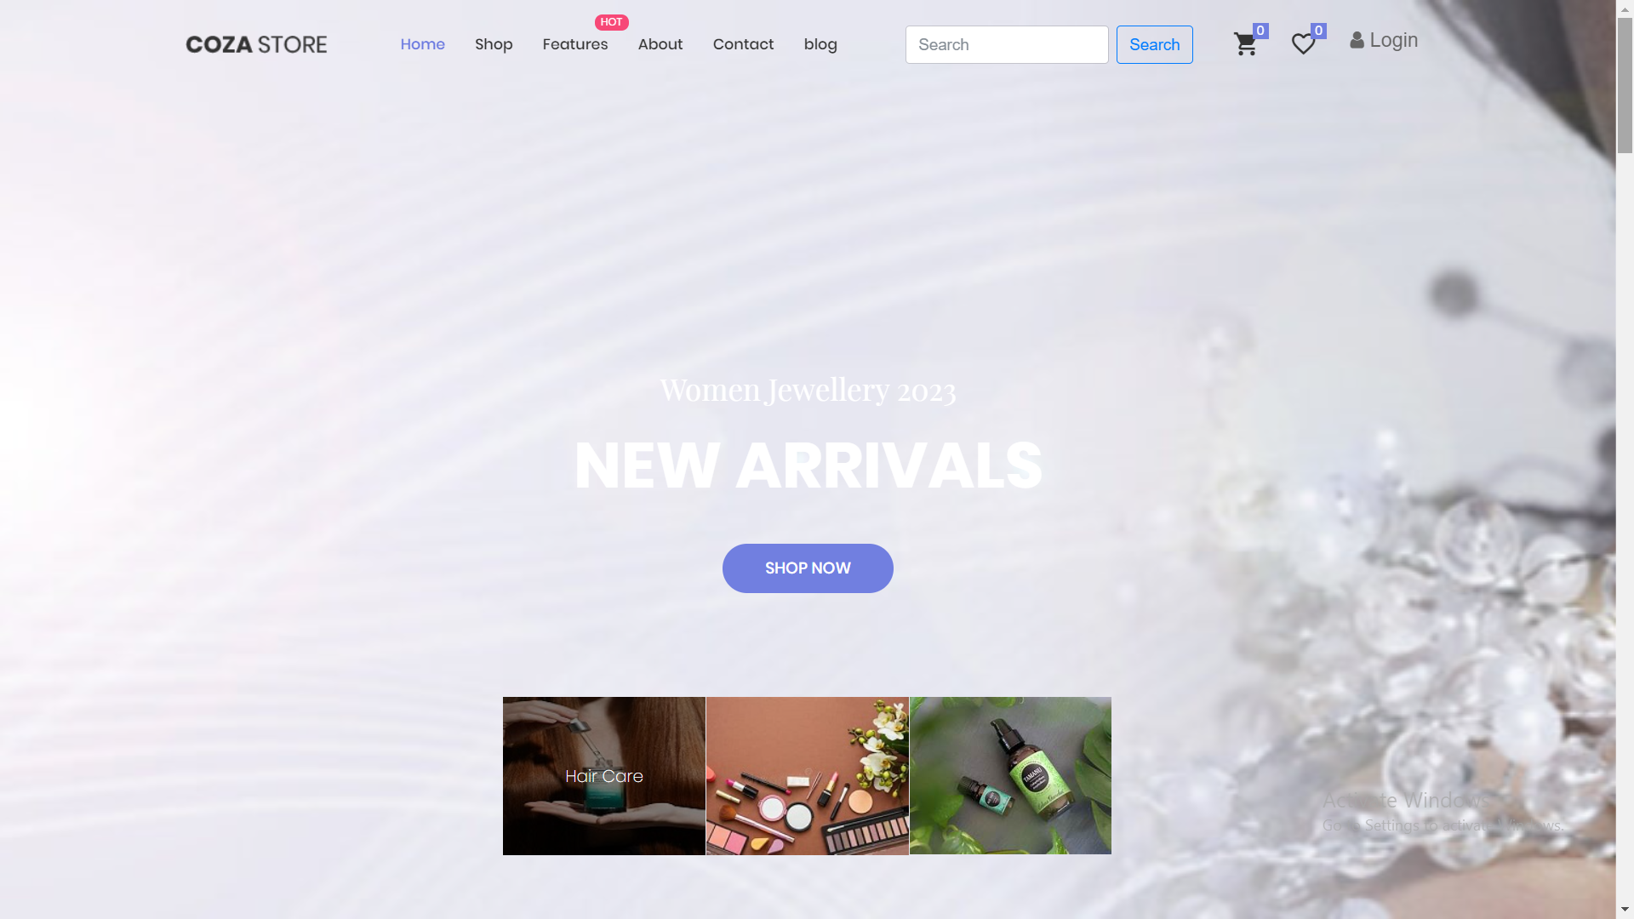

**How to use home page:**

Basically, home page is divided into two main parts:

1. Product cards
2. Brand cards

Gallery Section:

Cards section contain the cards of all type of product with price and product rating and small description with brand name to interact with customer in better way .

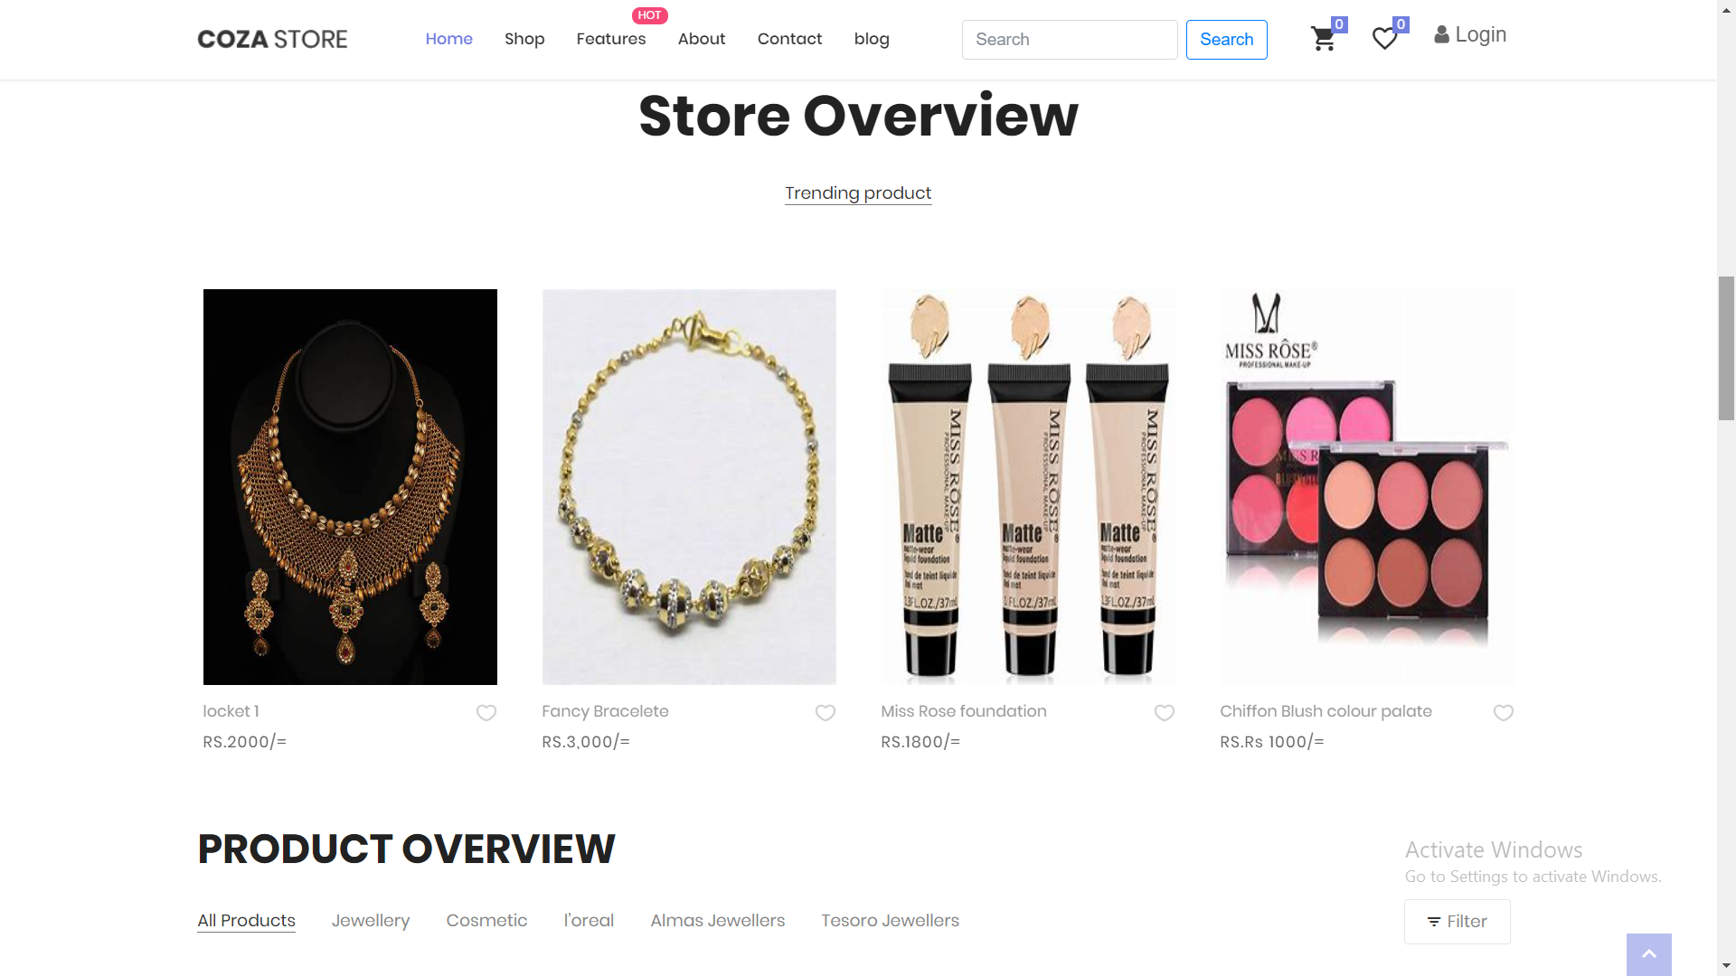

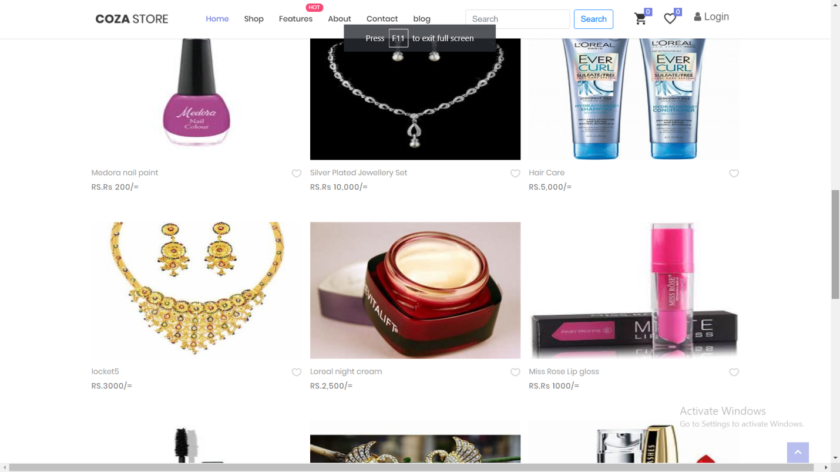.

After clicking quick view button you will be able to see product details

**NAVBAR-LINKS**

All the links on navbar are properly hyperlinked

There is the detailed information about:

Footer:

Our footer is divided into four parts **About Us, links , quick links contact**  quick links are hyperlinked from where you can navigate from one page to another page .And also you can connect with us on

Social media

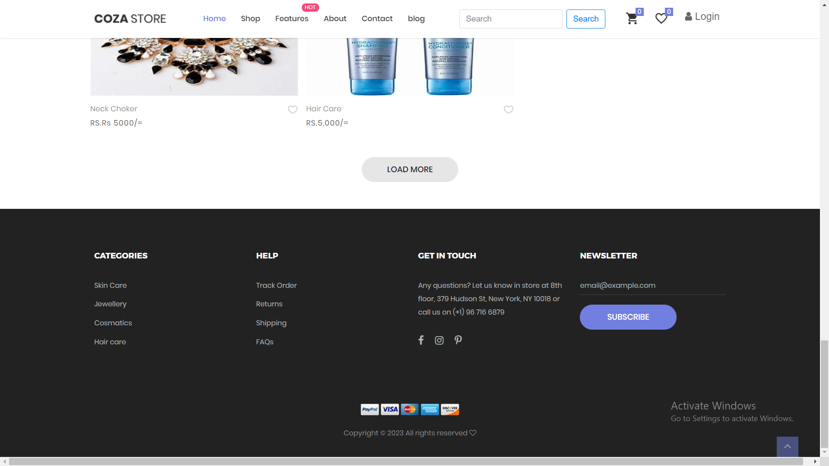

**Home Page Source Code:**

